Visual Excellence LTD

Operations Manual

Document Version 1.0
01 August 2022

Contents

Section 1 Introduction 3
1.1 Our Commitment to Safety 3
1.2 Record of Amendment 3
1.3 Understanding the Content of the Manual 3
1.4 Amending this Manual 3
Section 2. General 5
2.1 Company Operations 5
2.2 Address for Service and Primary Base of Operations 5
2.3 Legal Obligations 5
Section 3. Risk management 7
Section 4. Procedures for reporting information to the CAA 11
Section 5. Competency and Medical Requirements 12
Section 6. Aircraft 13
Section 7. Control System 14
Section 8. Maintenance and Initial Airworthiness Standards 15
Section 9. Flight Procedures 16
9.1 Uncontrolled Aerodromes 16
9.2 Property 16

Annexes (separate documents)
Annex A Pilot Medical Self-assessment
Annex B Planning and Operational Risk Assessment
Annex C Property Owner/Occupier Notification Form

Section 1 Introduction

1.1 Our Commitment to Safety
Visual Excellence is driven to maintain the highest possible safety standards. Our reputation is important to us and we will do everything we can to ensure that no-one is harmed, and no persons or property damaged from our activities.
We will provide our personnel with the best possible work environment, equipment, and training to operate safely.
Our approach to safety and the instructions to our personnel are contained within this manual and we are committed to ensure that it is current. We will actively involve our personnel to identify and implement safety improvements and reflect those improvements within this manual.

Signed:________________________ Chief Executive Officer (CEO)
Date:_______________

1.2 Record of Amendment
Amendment | Effective Date | Change detail
Initial Draft | 31 Jan 2022
Version 1.0 | 01 Aug 2022 | Contact details updated

1.3 Understanding the Content of the Manual
All personnel must be trained and assessed on the contents of this manual. A record of that assessment is retained within the individual’s training record. When changes are made to the manual, those changes will be brought to the attention of all personnel and appropriately documented.

1.4 Amending this Manual
1.4.1 When submitting changes to the CAA Visual Excellence will highlight any new text that has been added and strikethrough text that is no longer required. A summary of the changes made is recorded in section 0.2, including references to the effected pages and sections.
1.4.2 This manual will be continuously reviewed and updated as necessary. All personnel are encouraged to make submissions on the content of this manual. Submissions are to be submitted in writing to the Person with Primary Responsibility (the Prime Person).
1.4.3 CAA Form 24102-12 will be used to help determine if the proposed changes require CAA’s prior approval.
1.4.4 If CAA approval is required, details of the proposed amendments must be provided on CAA Form 24102/02.
1.4.5 All proposed changes made to this exposition will be submitted to CAA as soon as practicable.

Section 2. General

2.1 Company Operations
Visual Excellence conducts photography, videography, postproduction, editing, and production of promotional material. Small Remotely Piloted Aircraft Systems (RPAS or UAS) “drones” are used to conduct aerial photography and aerial videography.

2.2 Address for Service and Primary Base of Operations
Visual Excellence
Unit 2, Remote Way
Wellington

2.3 Legal Obligations
2.3.1 All operations must be carried out in accordance with the Civil Aviation Act, the Civil Aviation Rules, the Operation Specifications document and this manual.
2.3.2 Visual Excellence will also ensure that its operations comply with:
- Privacy Act
- Health and Safety at Work Act
2.3.3 Visual Excellence has been granted the following variations from CAR Part 101:

Uncontrolled Aerodromes
Visual Excellence conducts flights within 4km of uncontrolled aerodromes following the procedures within this manual including prior notification and engagement with the aerodrome operator.

Over Property
Visual Excellence conducts flights over property following the procedures in this manual including prior notification to the property owner or occupier.

2.4 Company Structure and Responsibilities
2.4.1 John Doe is the CEO and Prime Person for all Visual Excellence remotely piloted aircraft operations.
2.4.2 The CEO is responsible for setting the safety culture for the organisation and ensuring it is appropriately resourced.
2.4.3 The Prime Person is responsible for:
- ensuring continuing compliance with the Civil Aviation Act and Rules
- dissemination of information, including amendments to, and currency of, this Operations Manual
- ensuring that all staff operating under the Visual Excellence 102 UAOC are trained and competent to perform their duties on an on-going basis, and
- ensuring that all aircraft operated under the Visual Excellence 102 UAOC are airworthy and are appropriately maintained
- maintaining company hazard register
- identifying operational hazards, assessing the associated risks and controls and authorising the level of risk
- ensuring incidents and accidents are reported to CAA, and
- investigating all incidents and accidents.
2.4.4 The pilots are responsible for:
- ensuring flights are conducted safely and in accordance with Civil Aviation Rules, the company policy and procedures stated in this exposition
- briefing ground crew / observers or other personnel on site about the operation prior to flight
- reporting new hazards, risks or incidents and accidents to the Prime Person
2.4.5 The ground crew / observers are responsible for:
- attend crew briefings and following instructions of Pilot during flight operations
- preventing unauthorised access to the take-off/landing area
- monitoring the surrounding airspace and providing situational awareness to the pilot while the aircraft is in flight

Section 3. Risk management
This section describes how Visual Excellence conducts risk management for our organisation. Visual Excellence requires its pilots to apply their training and adopt a continuous process of identifying hazards, assessing risk, and taking action to eliminate or reduce risk.

  - Risk Management Procedures
All hazards, risks or safety issues will be reported to the prime person.
This is done using the Planning and Operational Risk Assessment form (PORA) (Annex B)., however these may also be reported by other communication means, such as phone, email or in person.
Operational hazards and risks that have been identified on a PORA form are subsequently transferred into the company’s hazard register.
The Prime Person is responsible for keeping the hazard register updated on a regular basis (at least 6 monthly) and to ensure risks or risk mitigations identified are communicated to all staff and stakeholders, customers or other parties as required.
The company’s hazard register is an excel spreadsheet held in the main document folder on Visual Excellence’s shared drive. It can be accessed by all staff at any time. The format of the hazard register is noted in section 3.4 below.
  - Identifying and analysing risks:
Visual Excellence uses a PORA form (Annex B) for every operation. It is the pilot’s responsibility to fill out the PORA. At the completion of each operation the PORA must be saved into the operations folder on the shared drive.
During both pre-flight planning / preparation and on site prior to flying, the pilot must identify any hazards that are present, assess the associated risks and record these on the PORA form. Pilots must then determine what mitigations or control measures will be applied to reduce these risks as low as is reasonably practicable. Consideration must be given to either eliminating, reducing or accepting the degree of risk. The hazard register and previous PORA forms may be used as a guide to help identify common hazards, the risks and effective mitigation measures. Be aware that known hazards and risks may require new mitigation strategies in different operating environments.
Once acceptable mitigations have been applied the risk matrix (table ‘A’) is used to determine the final risk rating.

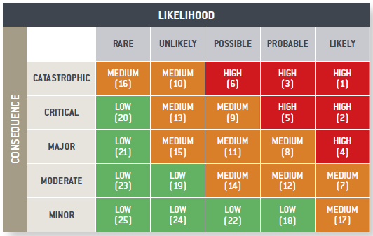
Table ‘A’ - Risk Matrix

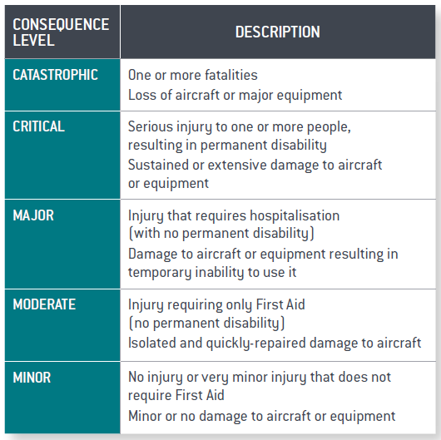
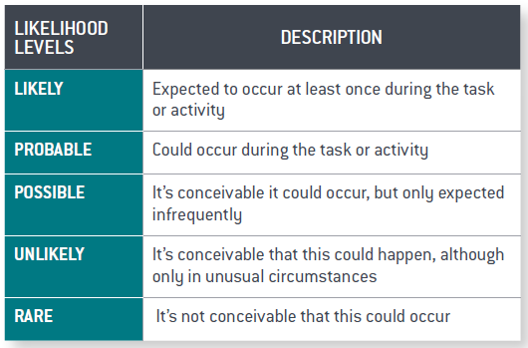

  - Risk Acceptance:
The risk rating calculated above now determines if the risk has been reduced to an acceptable level for the operation to proceed. (see table B)

HIGH - Unacceptable | Risk level unacceptable, do not proceed. Prime Person must be informed, and consideration given to what, if any additional action could be taken to reduce the risk to a lower level.
MEDIUM - Review | Further risk reduction / mitigation must be considered. Acceptance from the Prime Person is required before this operation can commence.
LOW - Acceptable | Risk is considered acceptable.
Table ‘B’ – Risk levels

Note: This process is also used where a new risk has been identified from a source other than a pilot using the PORA form, e.g. information provided by another operator, a client, or a landowner.

  - Hazard register format:
This is only an example of how hazards are recorded. The hazard register is available on our company shared drive.
# | Identify |  |  | Analyse
 | Hazard | Risk and impact on operations | Controls / mitigations | Consequence | Likelihood | Residual risk rating
1 | Manned aircraft in operational area | Crash with manned aircraft causing injury or fatality  Injury to person on ground.  Loss of UAV | Trained pilots  Use of air space observer in high manned traffic areas  Listening watch on aviation radio  Use of NOTAM (above 400ft) | Catastrophic | Rare | Medium
2 | Impact with vertical obstacles (tree/tall building) | Loss of UAV  Damage to structure  Injury to persons on ground | Trained pilots  Complete planning and pre-flight site checks  Remain Visual line of sight | Major | Rare | Acceptable
3 | Low visibility | Losing sight of aircraft, damage to aircraft, injury to persons, damage to property | Follow procedures and planning checklists to assess conditions  No operations in fog or cloud  Use of an observer to assist pilot | Minor | Possible | Acceptable
4
5

Section 4. Procedures for reporting information to the CAA
4.0.1 Visual Excellence aims to learn from incidents and accidents and proactively investigates those events.
4.0.2 The Prime Person is responsible for ensuring all incidents and accidents are reported to the CAA using CA005RPAS.
4.0.3 Visual Excellence will provide the CAA with accurate and relevant safety information. All incidents and accidents will be reported as soon as practicable and no later than ten days, with the final investigation report being provided within 90 days of the event.
4.0.4 If in doubt, Visual Excellence will report. A non-exhaustive list of reportable events includes:
- Flyaway
- Damage to aircraft
- Loss of control
- Loss of power
- Loss of visual line of sight
- Damage to property
- Injury to persons or fatality
- Structural failure
- Incidents involving manned aircraft
- Incursion into airspace where not authorised
4.0.5 Where appropriate Visual Excellence will contract the services of a specialist aviation safety investigator to assist with investigations.

Section 5. Competency and Medical Requirements
5.0.1 Visual Excellence ensures all its staff are trained to competently perform their duties, including ongoing re-currency training and competency assessment.
5.0.2 All Visual Excellence pilots must complete a Part 102 training course provided by an approved Part 141 Training Organisation. Pilots must also successfully pass an annual Operational Competency Assessment (OCA) conducted by an approved Part 141 Training Organisation.
5.0.3 As part of the pre-flight assessment, all Visual Excellence pilots must declare whether they are physically and medically fit to conduct the flight operations (see Annex A). This includes, but is not limited to, pilots ensuring that they are:
- Not under the influence of alcohol or drugs.
- Not under the influence of medication (either prescribed or over the counter) that may impair cognitive or motor function, eyesight or hearing.
- Not suffering from any medical condition that may impair cognitive or motor function, eyesight or hearing.
- Not suffering from the effects of sleep deprivation or fatigue.

Section 6. Aircraft
6.0.1 Visual Excellence operates DJI Inspire 2, Phantom 4, and Mavic series aircraft. All aircraft must be clearly labelled on the outside of the aircraft with:
- The company name.
- The company phone number.
- A unique number that identifies the individual aircraft.
6.0.2 New aircraft purchased will not re-use previously issued unique numbers.
6.0.3 An asset register is maintained that list all aircraft Visual Excellence have owned and their current status, including the date maintenance checks are completed and the flight hours at the time these were done.

Section 7. Control System
7.0.1 Visual Excellence uses the standard DJI control system that was provided with each aircraft. For some operations, Visual Excellence may also employ third party software that interfaces with the DJI control system where this has been specifically developed for that purpose.
7.0.2 Third party software includes:
  - MapMyFlight (Fictitious product – illustrative only)
  - Design MyFlight (Fictitious product – illustrative only)

Section 8. Maintenance and Initial Airworthiness Standards
8.0.1 Visual Excellence utilises standard unmodified DJI aircraft and follows the manufacturer’s maintenance and airworthiness guidance. All aircraft are purchased new from an authorised DJI supplier.
8.0.2 Visual Excellence takes particular care in the handling, storage, charging and replacement of Li-Po batteries due to the inherent hazards from these items. The Intelligent Flight Battery Safety Guidelines for the model of aircraft will be followed. This information is available from the DJI Downloads centre.
8.0.3 Visual Excellence inspects our DJI Inspire 2 aircraft in accordance with the manufacturer's maintenance manual (200 flights or 50hrs, whichever comes first). This task must be performed by the Prime Person or by a company pilot who has been authorised to do so by the Prime Person.
8.0.4 Visual Excellence will also inspect our other DJI aircraft at 200 flights or 50hrs, whichever comes first. Where no inspection schedule exists for these aircraft, the inspection will follow as closely as possible the Inspire 2 schedule noting that some items will be not applicable.
8.0.5 Additionally, Visual Excellence must obtain a maintenance check every 12 months for all aircraft from an appropriately qualified independent maintenance provider. Records of all maintenance conducted on each aircraft will be recorded in the assets register.
8.0.6 To capture the hours flown Visual Excellence use the automatically uploaded flight details on the DJI cloud account.

Section 9. Flight Procedures

9.1 Uncontrolled Aerodromes
When operating within 4km of any uncontrolled aerodrome Visual Excellence must:
- Notify and engage with the aerodrome operator prior to flight to determine what additional hazards need to be assessed.
- Use an observer.
- Remain below 400 feet AGL.
- Monitor the aerodrome radio frequency.
- Remain well clear of any manned aircraft. In most cases this will mean landing the Visual Excellence aircraft until the other aircraft no longer presents a hazard.
Visual Excellence uses Airshare as its primary means of establishing the location of aerodromes but also checks this information with the current Visual Navigation Charts. The distance from the aerodrome boundary to the intended job site must be verified by using the measurement function on Google Maps. Contact details for the aerodrome operators are contained in New Zealand Aeronautical Information Publication (AIP) at www.aip.net.nz
Pilots are reminded that discrepancies in aerodrome information can exist between Visual Navigation Charts (VNC), NZ AIP, and Airshare so care must be exercised when planning and conducting operations near aerodromes.
Care must also be taken when planning operations in rural areas as locations of many agricultural airstrips are not shown on Airshare, VNC or the AIP. Visual Excellence will exercise extreme caution when operating near agricultural airstrips and must be considered during the risk assessment process.
9.1.1 Notification to aerodrome operators will be provided in writing (email or letter), no less than 24 hours before the intended operations whenever possible.
Where no acknowledgement has been received from the aerodrome operator, or notification can’t be provided within 24 hours of the intended operation, pilots must make contact with the aerodrome operator by phone or in person to confirm receipt of the notification, and to engage with them about any hazards to be mitigated.
9.1.2 Pilots must also be careful when planning operations within 4kms of aerodromes as some uncontrolled aerodromes are located within controlled airspace. In these circumstances, a clearance must be obtained from the responsible Air Traffic Control (ATC) service via Airshare. An ATC clearance does not absolve the pilot from the uncontrolled aerodrome notification and engagement requirements stipulated above.

9.2 Property
When operating over property without consent from the owner/occupier Visual Excellence must:
- Notify the owner/occupier prior to flight using Property Owner/Occupier Notification Form (Annex C).
- Modify the operation based on any additional hazards communicated by the owner/occupier

